ASTRA 6 Report Experiment3
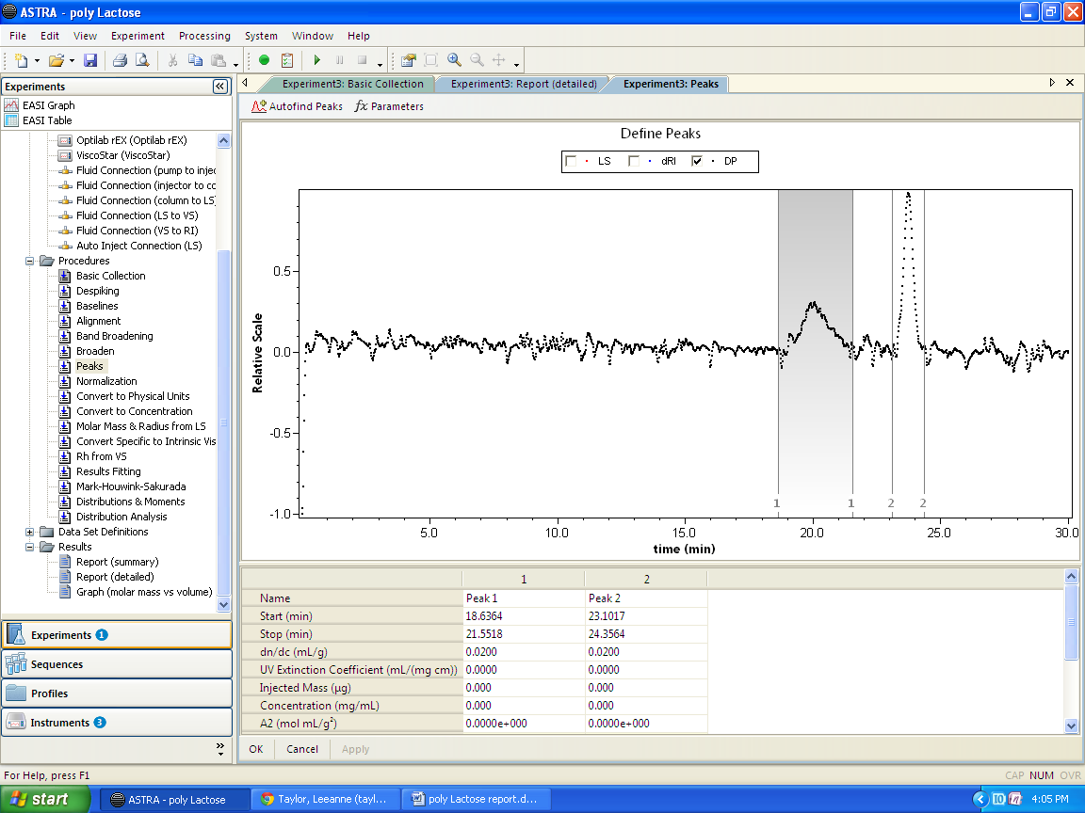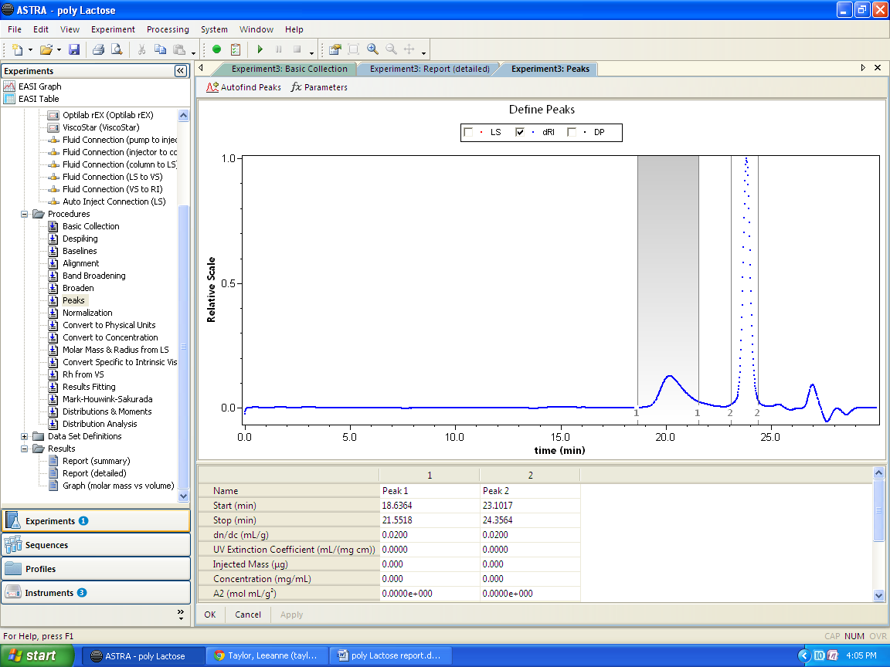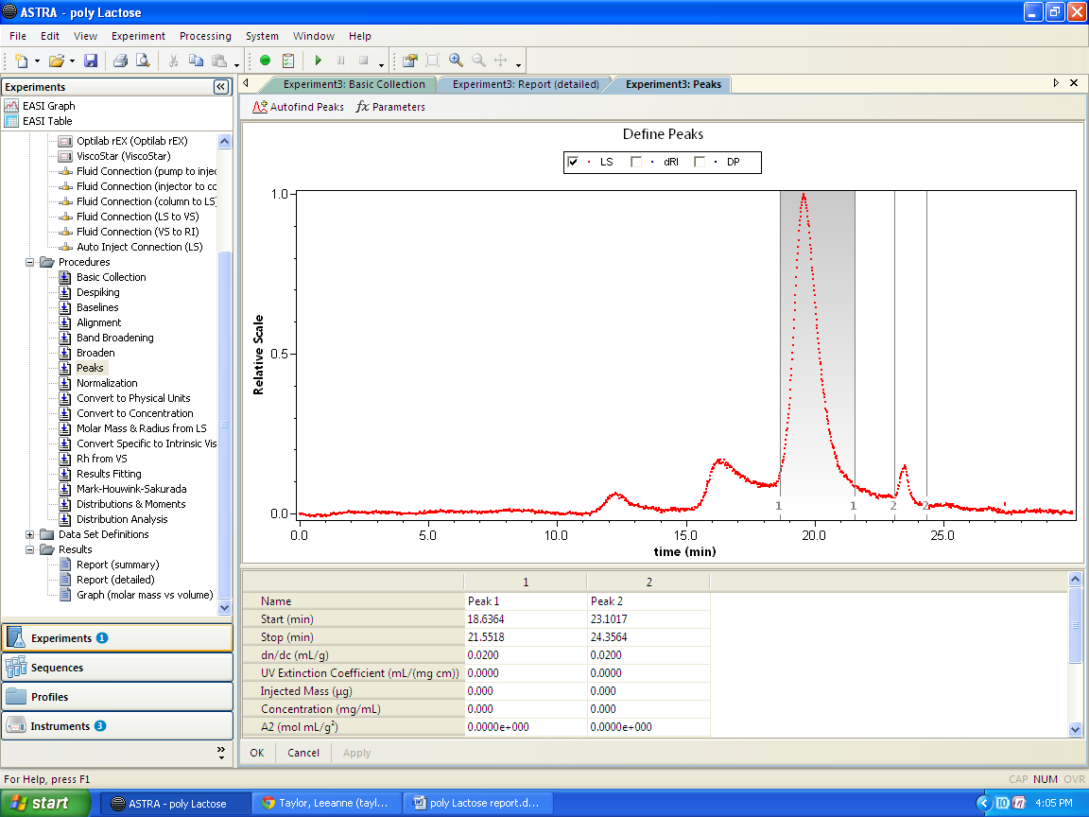
File Name: Experiment3
Collection Operator: AYRESGPC\Ayres Research Group (AYRESGPC\Ayres Research Group (Ayres Research Group))
Processing Operator: AYRESGPC\Ayres Research Group (Ayres Research Group)

Sample: sample
Concentration: 7.700 mg/mL

Configuration
Concentration Source: RI
Flow Rate: 1.000 mL/min

Light Scattering Instrument: miniDAWN TREOS
Band Broadening Correction: n/a
Cell Type: Fused Silica
Wavelength: 656.0 nm
Calibration Constant: 6.1050×10⁻⁵ 1/(V cm)
Detector | Scattering angle | Gain | Normalization coefficient
1 | 46.6º | n/a | 0.745
2 | 90.0º | n/a | 1.000
3 | 133.4º | n/a | 0.837

RI Instrument: Optilab rEX
Band Broadening Correction: n/a
Wavelength: 658.0 nm

Viscometer: ViscoStar
Band Broadening Correction: n/a
Dilution Factor: 0.4976

Solvent: thf
Refractive Index: 1.402
Fluid Connections
Source Instrument | Destination Instrument | Delay Volume (mL)
Generic Pump | Injector | 0.000
Injector | Generic Column | 0.000
Generic Column | miniDAWN TREOS | 0.000
miniDAWN TREOS | ViscoStar | 0.000
ViscoStar | Optilab rEX | 0.000

Processing
Collection Time: Monday January 27, 2014 03:10:18 PM Eastern Daylight Time
Processing time: Monday January 27, 2014 03:52:13.218 PM Eastern Daylight Time

Basic Collection:
LS Instrument Collection Interval: 1.000 sec

Baselines:
Series | Start | Stop | Type
detector 1 | (5.352, 0.051) | (29.547, 0.051) | manual x, auto y
detector 2 | (3.995, 0.030) | (29.585, 0.030) | manual x, auto y
detector 3 | (3.467, 0.039) | (29.811, 0.039) | manual x, auto y
differential refractive index data | (4.657, -0.000) | (29.671, -0.000) | manual x, auto y
Differential Pressure | (7.023, -0.000) | (29.890, 0.000) | manual x, auto y

Peak settings:
Peak Name | Peak 1 | Peak 2
Light Scattering Model | Zimm | Zimm
Fit Degree | 1 | 1
dn/dc (mL/g) | 0.0200 | 0.0200
A2 (mol mL/g²) | 0.000 | 0.000
Injected Mass (µg) | 0.000 | 0.000
Viscometry Model | Huggins | Huggins
Huggins Equation Parameter | 0 | 0
Kraemers Equation Parameter | 0 | 0

Results Fitting Procedure:
Data | Fit Model | Degree | R² | Extrapolation

Results
Peak Results
 | Peak 1 | Peak 2
Masses
Calculated Mass (µg) | 555.81 | 1391.88
Molar mass moments (g/mol)
Mn | 7.030×10⁴ (±12.639%) | 1.471×10³ (±31.951%)
Mp | 7.508×10⁴ (±8.397%) | 1.526×10³ (±43.211%)
Mv | 7.763×10⁴ (±-1.589%) | 1.695×10³ (±-7.807%)
Mw | 1.315×10⁵ (±5.706%) | 6.311×10³ (±50.799%)
Mz | 4.505×10⁵ (±7.514%) | 8.004×10⁴ (±133.120%)
Mz+1 | 9.393×10⁵ (±3.804%) | 1.247×10⁵ (±148.717%)
M(avg) | 3.442×10⁵ (±0.142%) | 1.670×10³ (±3.126%)
Polydispersity
Mw/Mn | 1.871 (±13.867%) | 4.291 (±60.012%)
Mz/Mn | 6.409 (±14.704%) | 54.420 (±136.901%)
rms radius moments
Rn | n/a | n/a
Rw | n/a | 52.6 (±58.2%)
Rz | n/a | 136.9 (±21.9%)
R(avg) | 60.5 (±10.8%)
Intrinsic viscosity moments (mL/g)
ηn | 1.566 (±22.003%) | 0.582 (±7.125%)
ηw | 1.86 (±24.75%) | 0.70 (±8.88%)
ηz | 3.052 (±52.717%) | 1.846 (±10.169%)
η(avg) | 1.785 (±1.505%) | 0.794 (±0.772%)
Hydrodynamic radius moments (nm)
Rh(n) | 2.5 (±8.4%) | 0.5 (±12.2%)
Rh(w) | 3.1 (±7.9%) | 0.7 (±15.7%)
Rh(z) | 5.5 (±10.7%) | 2.6 (±21.1%)
Rh(avg) | 2.9 (±0.6%) | 0.5 (±2.0%)
Mark-Houwink-Sakurada a: -0.381 (±-0.691%)
Mark-Houwink-Sakurada K: 1.048×10¹ (±2.877%) mL/g

